PROJECT DOCUMENT

Jobs created

- app_compile
- app_test
- app_code_coverege
- app_package

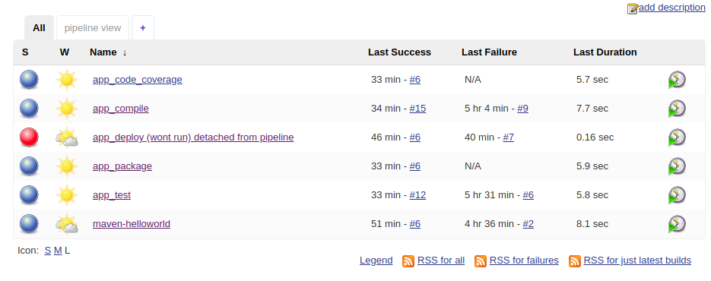
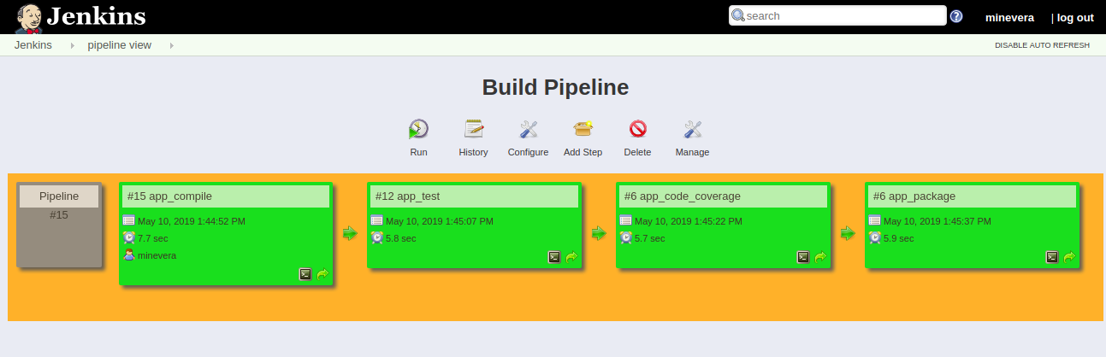
Pipeline view
Next job is triggered only if the first job is successful. I will also add Junit report by eod.

Region: N.Virginia

Servers Used

- Minevere Web Server (Deployment Server)
- Minevera CI/CD (Jenkins Server)
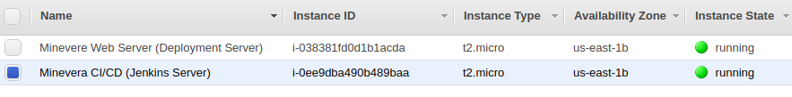

public ip at time of instance creation : 54.89.184.196
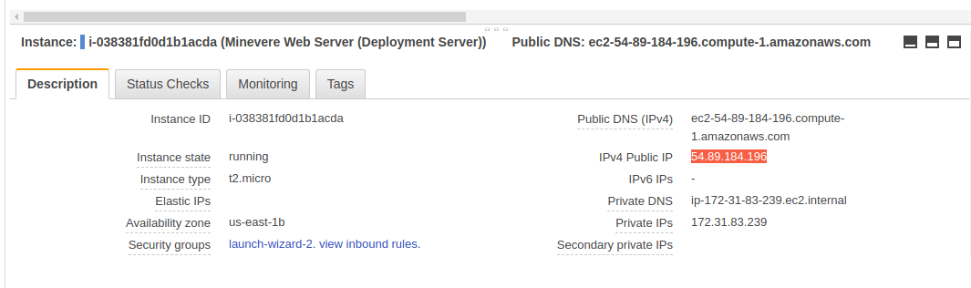

Result generated after packaging and deployment:

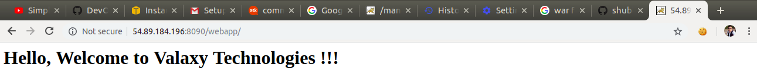
war file:
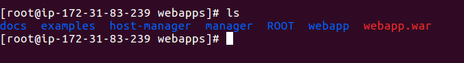

TOOLS / TECHNOLOGIES Used:
- Jenkins
- AWS
- Apache Tomcat

